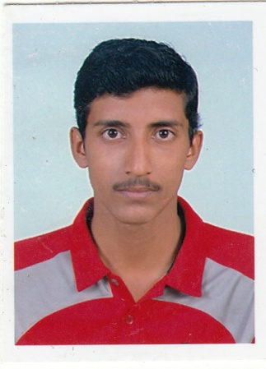  PADMARAJ A  Mobile No. : +91 9895124325  Email: padmaraja7@gmail.com  Address:  TC 28/322, seeveli nagar,  Kaithamukku,  Pettah P.O,  Trivandrum-695014 | 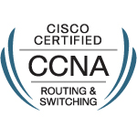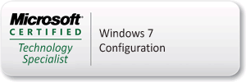  CAREER OBJECTIVE  To secure a position that will explore and upgrade my skills & knowledge, thereby achieving both personal and professional goals for the mutual benefits of the organization and myself.  PROFFESIONAL EXPERIANCE  - Team Leader(Netsoft Consulting services private limited) – Educomp Smartclass Project,Thiruvananthapuram (june 2011 – till date)  Job responsibilities include:-  - Manage all development team and report to higher management  - Maintaining Operating System  - Troubleshooting various issues in Networks  - Troubleshoots Issues of Projectors,Ups,and Other Hardwares  - Contact Vendors ,on warranty issues  - Updating Call details in CRM  - Network support engineer at Innoz technologies (P) Ltd, Trivandrum (Dec 2009-Dec 2010)  Job responsibilities include:-  - Assembling and troubleshooting  - Maintaining Operating System  - Troubleshooting various issues in Networks  - Technical supporter-Network at Indiaoptions software (P) Ltd, Trivandrum (July 2009-Nov 2009)  Job responsibilities include:-  - Assembling and troubleshooting  - Maintaining Operating System  - Troubleshooting various issues in Networks  CERTIFICATIONS  - MCTS – Microsoft Certified Technology Specialist:  Windows 7 configuration  - CCNA – Cisco Certified Network Associate  TECHNICAL COURCES  - CCNA – Cisco Certified Network Associate  - MCITP - Microsoft Certified IT Professional  - A+  EXPERIENCE DETAILS  COMPANY: AL MUROOJ ROTANA HOTELS & SUITES  DESIGNATION: INFORMATION TECHNOLOGY SUPERVISOR  YEAR: SEPTEMBER 2011 –  COMPANY: ECIT  DESIGNATION: HARDWARE & NETWORKING ENGINEER  YEAR: DECEMBER 2009 – FEBRUARY 2011  - Hands-on experiences in configuration & troubleshooting of CISCO 2500,2600 series Routers and 2950 Switches.  - Troubleshooting various hardware and software problems, maintaining and repairing or upgrading as needed.  - Maintain all computer hardware and software for both on and off site locations and optimizes operating systems.  - PC assembling, Installation and Maintenance of Software and Hardware, Printer, Antivirus security.  - Involved in Training Hardware & Networking Trainees and Students.  CERTIFICATION  CCNA – CISCO CERTIFIED NETWORK ASSOCIATE  MCP – MICROSOFT CERTIFIED PROFESSIONAL  HARDWARE & NETWORK MAINTENANCE
  Transcript ID -1038937
  ACCESS CODE – D624FB6F
  Cisco id: CSCO12386907
Course | Institution, University | Year
B.tech  Computer science | Kannur University | 2009
XII | SMV Govt. model B H S S, Trivandrum | 2005
X | Govt.Model B H S S, Trivandrum | 2003

TECHNICAL SKILL SET

- Installation & configuration of LAN (Win NT, Win 2000, Win 7)
- Computer Networking, Computer Hardware, PC Assembling.
- CCNA, CCNP. MCSE (course completed)
- Got A grade in PC hardware and networking

SOFTWARE EXPOSURE

Operating Systems : - Windows XP, Windows Vista, Windows7,Win 8.
Tools : - Microsoft Outlook, Microsoft Office, Adobe Photoshop, MS office etc.
EXTRA CURRICULAR ACTIVITIES
- Active in sports activities.
- Event organizer in college functions and other events.
- Team member in college cricket team.
- Playing Cricket, Football and badminton etc…

PERSONAL PROFILE

Father’s Name : Ayyappan pillai.
Date of Birth : 31st october 1987.
Sex : Male.
Nationality : Indian.
Marital Status : Single.
Languages Known : English, tamil & Malayalam.
Passport Number : H6421835

REFERENCES

- Adheesh Nair
ITA
KTDC
+919840575055
adheeshnair@gmail.com

I hereby declare that all the particulars given above are true to the best of my knowledge.
PADMARAJ A

