Curriculum Vitae 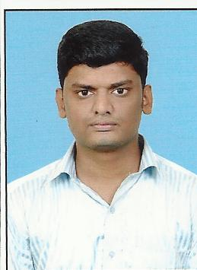
Career Objective:
Seeking a responsible job with an opportunity for professional challenges.

1. Personal Information:

Name : Ganesh. N

Qualification : Diploma Computer Science & Engineering
(BE) Computer Science & Engineering.

Work Experience : ACME Technology E-Book Publishing using with XML Language.

2. Software Proficiency:
- Languages : C,C++.
- DBMS Packages : Oracle.
- Web Designing : HTML, XML, PHP.
3. Academic Details:
3.1 Academic Performance:
Sl. Nb. | Name Of Institution/University | Name Of Examination | Year Of Passing | Percentage Of marks | Class/Grade
1 | Cape Institute of Technology, Levengipuram, Tvli Dist, Anna University,Tamil Nadu. | BE | 2012 | Course completed | Course completed
2 | Kalaivanar N.S.K Polytechnic college, Chenbagaramanpudur, State Board of Technical Education, Tamil Nadu. | Diploma | 2009 | 67.79% | First Class
3 | Government High School, Putheri, K.K.Dist, Tamil Nadu State Board. | 10th Std | 2004 | 71.2% | First Class

4. Project Experience:
Project: Online Engineering Counseling.
The project ONLINE ENGINEERING COUNSELING is developed to create a website for interactive online counseling between students and counseling administrators. This project is based on Internet technologies. This provides advantage of doing counseling process at same time from different centers all over the places in a state.
This project is developed with ASP.NET & SQLSERVER as backend.
  - Project: Donor Information System
The DONOR INFORMATION SYSTEM for college is to know the details of the students who wish to become donors. Commercially this system will be more efficient and there is no performance delay. This system can be potentially used in any institution after customizing and can be automated with higher level of data security.
The technologies selected for DONOR INFORMATION SYSTEM are PHP, MYSQL & XAMPP SERVER.
5. Personal Skills:
- Able to work under pressure efficiently and carefully.
- Excellent organizational skills.
6. More about Myself:

Fathers Name : Nallakuttalam Pillai.A (TNEB Rtd.)

Mother Name : Anandham.K

Brother Name : Anancha Perumal.N; BE. Project Manager; Glow Networks
Private Limited (A CSS CORP Company).

Date of birth : 14th May 1989.

Marital Status : Single.

Contact Address : 2-226, South Street,
MelaPutheri, Nagercoil.
Kanyakumari District – 629001.
Contact No : 9003780599.
Email id : ganeshnpillai@gmail.com.
Languages Known : Tamil and English.
Reference:
K.Kantha Krishnan,
Madipakkam,Chennai-91.
7.declaration:
I here by declare that all the details furnished above are true to the best of my knowledge.
Place: Your’s faithfully

Date:
( N.GANESH)

